EXERCISE 2
- Write the SELECT statement to extract the ids of employees who are more than 30 years of age.
select ids from employee_data WHERE age > 30;
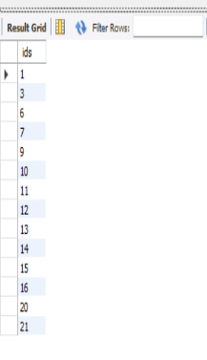

- Write the SELECT statement to extract the first and last names of all web designers.
select f_name, l_name from employee_data where title = "Web Designer";
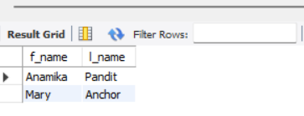

- What will the following SELECT statement display:
SELECT * from employee_data where salary <=100000;
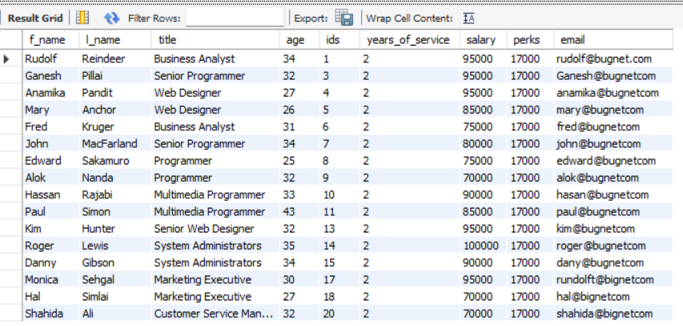

- How will you display the salaries and perks for employees who have more than $16000 as perks?
select salary, perks from employee_data where perks > 16000;

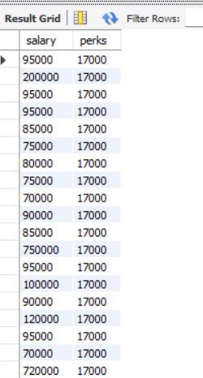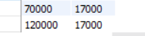
- List all employee names (last name followed by first name) who hold the title of Marketing Executive.
select l_name ||''|| f_name as full_name from employee_data WHERE title = 'MARKETING EXECUTIVE';
